University of Central Missouri

Department of Computer Science & Cybersecurity

CS5760 Natural Language Processing

Fall 2026

Homework 2.

Student name: Ruyi Gai

Submission Requirements:
- Once finished your assignment push your source code to your repo (GitHub) and explain the work through the ReadMe file properly. Make sure you add your student info in the ReadMe file.
- Submit your GitHub link on the Bright Space.
- Comment your code appropriately IMPORTANT.
- Any submission after provided deadline is considered as a late submission.

Part I. Writing Calculation
Q1. Worked Example Document Classification (based on slide: Test document “predictable no fun”)
Using the smoothed likelihoods and priors from Q2, compute the probability scores for the document “predictable no fun” under both the positive and negative classes.

Tasks:
- Show each step of the multiplication.
- Which class should the system assign to this document?
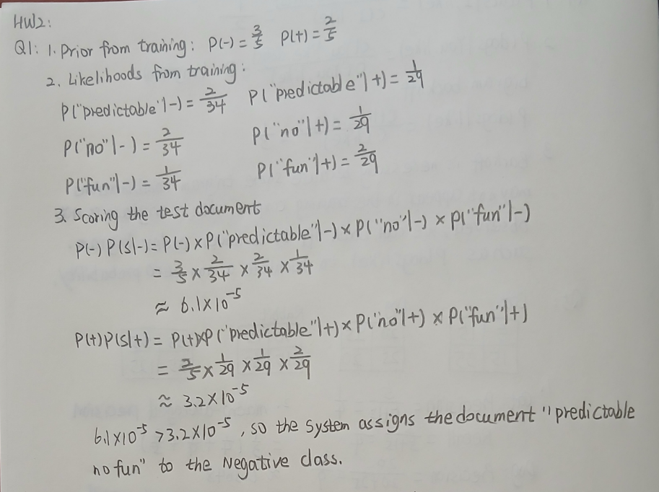
Q2. Harms of Classification (based on slide: Avoiding Harms in Classification)

Tasks:
- Define representational harm and explain how the Kiritchenko & Mohammad (2018) study demonstrates this type of harm.
Representational harm is harm caused by a system that demeans a social group, such as by perpetuating negative stereotypes about them.
Kiritchenko and Mohammad (2018) examined 200 sentiment analysis systems on pairs of sentences that were identical except for the names. They found that the systems assigned lower sentiment and more negative emotion to sentences with African American names (e.g., Shaniqua) compared to those with European American names (e.g., Stephanie). This can perpetuate negative stereotypes about African Americans and lead to downstream harm, as African Americans may be treated differently by NLP tools like sentiment analysis, which are widely used in marketing research, mental health studies, and other domains.
- What is one risk of censorship in toxicity classification systems (based on Dixon et al. 2018, Oliva et al. 2021)?
One risk is that toxicity classifiers may incorrectly flag non-toxic sentences that simply mention minority identities, such as words like "blind" or "gay". This can lead to censorship of speech by disabled people and other groups and make their speech less visible online.
- Give one reason why classifiers may perform worse on African American English or Indian English, even though they are varieties of English.
One reason is that text classifiers may perform worse on different varieties of English because of lack of representative data or labels for those varieties.

Q3. Bigram Probabilities and the Zero-Probability Problem
You are given the following bigram counts from a small training corpus:
Previous word | Next words (with counts)
<s> | I: 2 , deep: 1
I | love: 2
love | NLP: 1 , deep: 1
deep | learning: 2
learning | </s>: 1 , is: 1
NLP | </s>: 1
is | fun: 1
fun | </s>: 1
ate | lunch: 6 , dinner: 3 , a: 2 , the: 1

Tasks:
- Bigram Sentence Probabilities
Using maximum likelihood estimation (MLE):
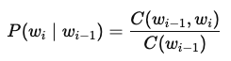
  - Compute the probability of sentence S1: <s> I love NLP </s>.
  - Compute the probability of sentence S2: <s> I love deep learning </s>.
  - Which sentence is more probable under the bigram model?
- Zero-Probability Problem
Using the same table, compute:
  - P(noodle∣ate) with MLE.
  - Explain why this probability creates problems when computing sentence probabilities or perplexity.
  - Apply Laplace smoothing (Add-1) to recompute P(noodle∣ate). Assume the vocabulary size is 10 and total count after “ate” is 12.
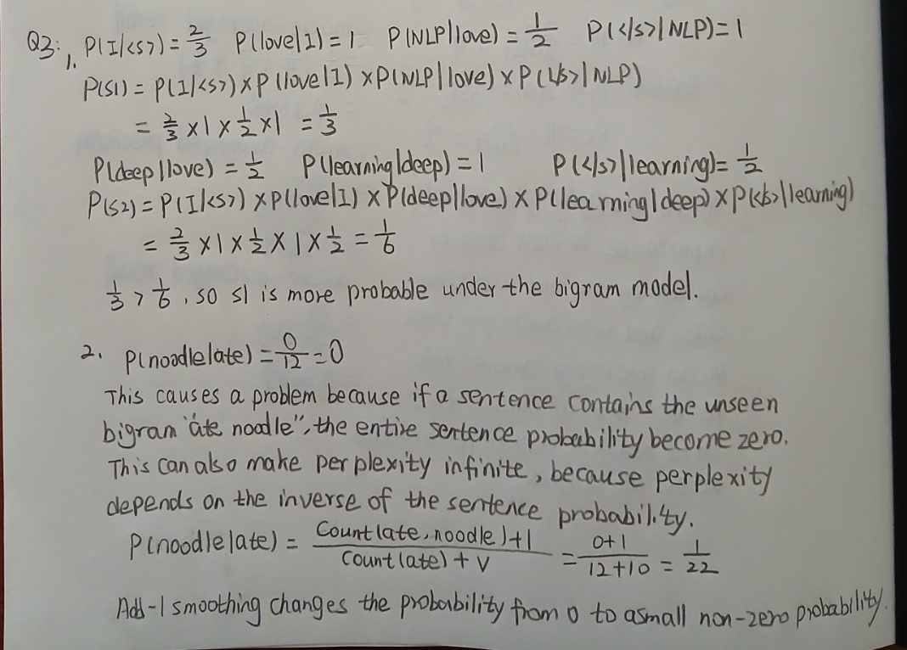

Q4. Backoff Model (based on “Activity: <s> I like cats … You like dogs” slide)
Training corpus:
<s> I like cats </s>
<s> I like dogs </s>
<s> You like cats </s>
Counts:
- I like = 2
- You like = 1
- like cats = 2
- like dogs = 1
- cats </s> = 2
- dogs </s> = 1

Tasks:
- Compute P(cats∣I,like).
- Compute P(dogs∣You,like) using trigram → bigram backoff.
- Explain why backoff is necessary in this example.
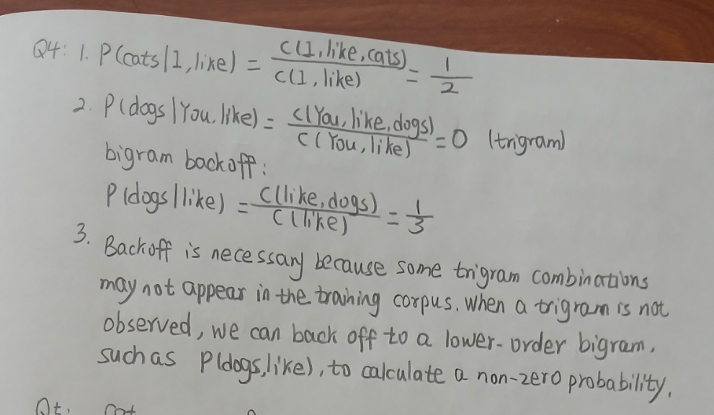

Q5: Evaluation Metrics from a Multi-Class Confusion Matrix
The system classified 90 animals into Cat, Dog, or Rabbit. The results are shown below:
System \ Gold | Cat | Dog | Rabbit
Cat | 5 | 10 | 5
Dog | 15 | 20 | 10
Rabbit | 0 | 15 | 10

Tasks:
- Per-Class Metrics
  - Compute precision and recall for each class (Cat, Dog, Rabbit).
- Macro vs. Micro Averaging
  - Compute the macro-averaged precision and recall.
  - Compute the micro-averaged precision and recall.
  - Briefly explain the difference in interpretation between macro and micro averaging.
- Programming Implementation
Write Python code that:
  - Accepts the confusion matrix above as input.
  - Computes per-class precision and recall.
  - Computes macro-averaged and micro-averaged precision and recall.
  - Prints all results clearly.
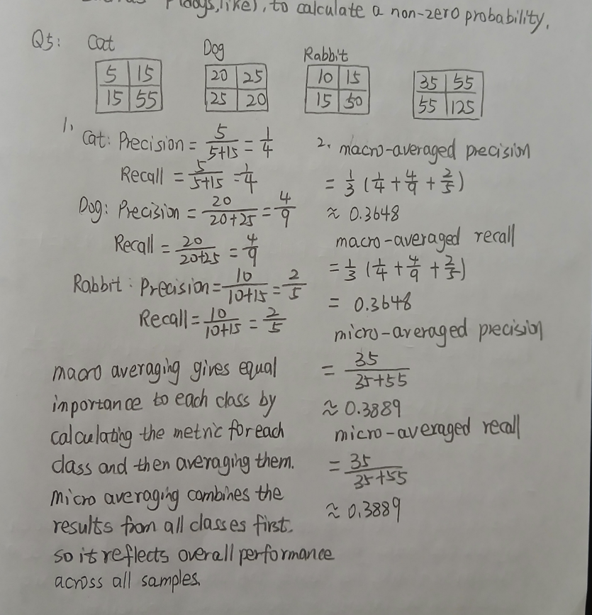
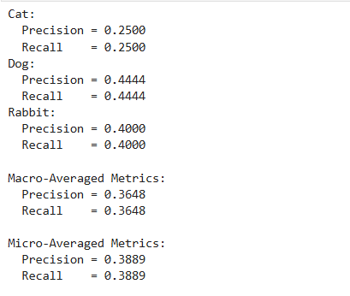
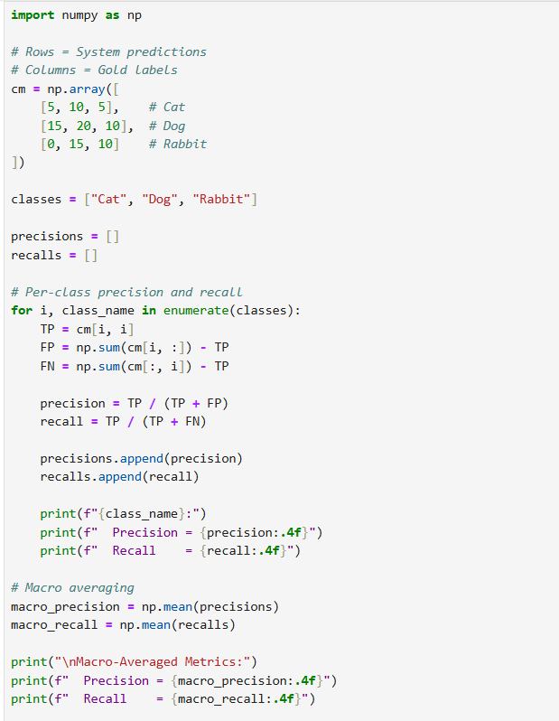
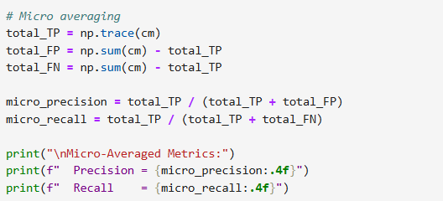

Part II. Programming

Q1. Programming: Bigram Language Model Implementation (based on “Activity: I love NLP corpus” slide)

Tasks:
Write a Python program to:
- Read the training corpus:
- <s> I love NLP </s>
- <s> I love deep learning </s>
- <s> deep learning is fun </s>
- Compute unigram and bigram counts.
- Estimate bigram probabilities using MLE.
- Implement a function that calculates the probability of any given sentence.
- Test your function on both sentences:
  - <s> I love NLP </s>
  - <s> I love deep learning </s>
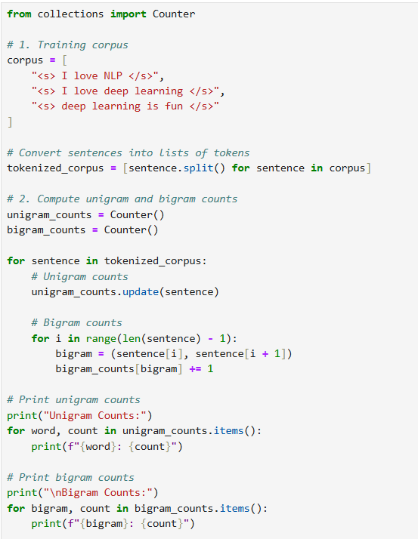
- Print which sentence the model prefers and why.
